Deploying a Radar Cross Section Prediction Artificial Intelligence to Ground Based Radars
Phantom Impact Paper
Artificial Intelligence Review Journal

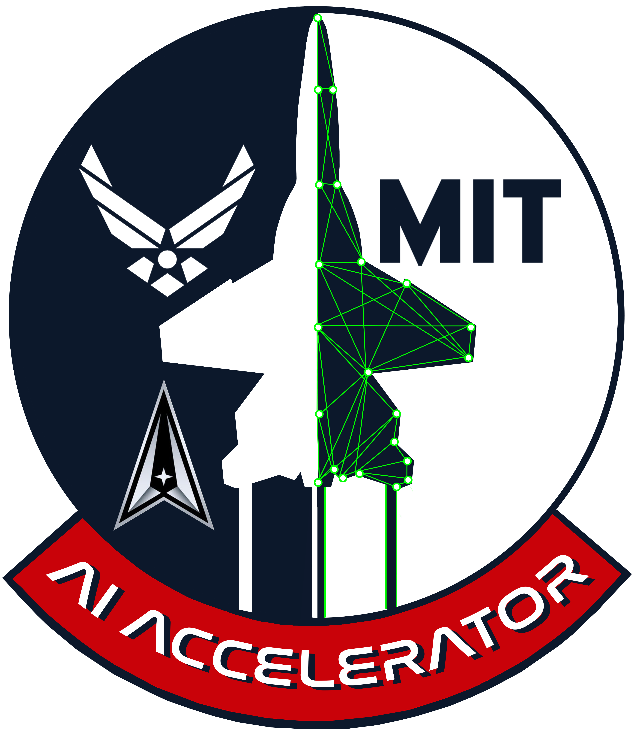

Author:
1st Lt Andrew D. Pham, U.S. Space Force
Lt Pham is a software development lead at Space Delta 4 Combat Developments and technical fellow with the DAF-MIT AI Accelerator. He is coded as a space operations officer specializing in orbital warfare with a Z-prefix designation for agile software development and cyberspace engineering, also known as a Supra Coder. Lt Pham has contributed to codebases around the DAF including Section 31 Kobayashi Maru, Space Camp, and Kessel Run. A graduate of Harvard University’s software engineering program, Lt Pham’s academic interests are in artificial intelligence and quantum computing.

Abstract:
RCS is a correlation criterion for space operators identifying satellites. Sometimes through maneuver or natural movement, a satellite’s RCS may change over time. This change may be predicted with ML regression to help space operators correlate objects. In this project, RCS prediction is implemented at ground based radars to warn space operators of changes. The process reveals one possible pipeline for transitioning fundamental AI research to software usable by guardians.

AI Accelerator Phantom Fellowship Program

The Phantom Fellowship is a rigorous five-month career-enhancing opportunity for high-performing Department of Defense professionals to assess, develop, and gain exposure to Artificial Intelligence (AI) and Machine Learning (ML) technologies. During the program, enlisted, officer, and government civilian personnel (Phantoms) embed directly with the Department of the Air Force (DAF) & Massachusetts Institute of Technology (MIT) AI Accelerator (AIA), a cutting-edge organization with the mission of advancing AI/ML technologies for the DoD while also addressing broader societal and ethical issues related to AI/ML.

During their Fellowship, Phantoms are required to apply their newly acquired AI/ML foundational knowledge to produce a short-form research paper (Impact Paper) that seeks to address an AI/ML problem related to their home unit and/or career field.
Deploying a Radar Cross Section Prediction Artificial Intelligence to Ground Based Radars

Andrew Pham
DAF-MIT AI Accelerator
United States Space Force
Cambridge, MA
andrew.pham.3@spaceforce.mil

Abstract—RCS is a correlation criterion for space operators identifying satellites. Sometimes through maneuver or natural movement, a satellite’s RCS may change over time. This change may be predicted with ML regression to help space operators correlate objects. In this project, RCS prediction is implemented at ground based radars to warn space operators of changes. The process reveals one possible pipeline for transitioning fundamental AI research to software usable by guardians.
Keywords—satellite, radar cross section, ground based radar, space domain awareness, artificial intelligence, machine learning, deep neural network, deep learning, supervised learning.

Introduction
Ground based radars (GBRs) primarily operated by the US Space Force assist with Space Domain Awareness (SDA) by tracking objects in orbit. These radars automatically detect and report metrics to space operators. Sometimes through some adjustment of rotation, angle, or maneuvers, a satellite’s radar cross section (RCS) may change over time. The radar’s system typically automatically updates an object’s RCS upon detection. However extreme dips in RCS can sometimes cause the automated system to mark an object as an uncorrelated target (UCT). Space operators upon seeing a UCT must report to the 18th Space Defense Squadron (18 SDS) potentially causing a cascade of actions at 18 SDS, The National Space Defense Center, and Combined Space Operations Center. If there were a way to anticipate this problem, tactics could be adjusted in mission planning beforehand to correctly correlate the target. RCS prediction may also help operators better suggest identification to the 18 SDS upon seeing a UCT. With new data being collected, RCS can be predicted with artificial intelligence (AI) regression techniques enabling advanced warning of this anomaly. Implementing this relatively simple machine learning (ML) application reveals a potential pathway for operationalizing an AI capability and enables the use of AI libraries on a Space Force platform.

Background
SDA is accomplished through the Space Surveillance Network (SSN), a global network of radars, optical telescopes, and space based sensors. The goal of the SSN is to keep reliable and current information on objects in space [1]. Sensors are divided into three categories: dedicated sensors solely supporting the SSN mission, collateral sensors with a primary mission other than space surveillance, and contributing sensors owned by other agencies that provide support upon request. The SSN is commanded and controlled by the 18th SDS. SDA is the mission and responsibility of Space Delta 2 to enable space battle management and support ground operations. Space Command’s catalog lists 54,200 objects including 14,102 satellites as of 2022.
Radar cross section is a measure of how detectable an object is by radar; it is typically measured in square meters or decibels relative to square meters corresponding to the angle, size of the object, material of the object, and polarization of the radiation. Because RCS is a property of an object’s reflectivity, the strength of the radar emitter and distance to the object do not affect the RCS [2]. Satellites can have a wide range of radar cross sections, from small CubeSats with cross sections on the order of a few tenths of a square meter, to large communication or reconnaissance satellites with cross sections on the order of tens or hundreds of square meters. The RCS of a satellite is constantly changing by a small amount as the angle from the sensor to the satellite changes with the satellite’s orbit.
Many satellites need to have their payloads, such as sensors and antenna, continuously pointed “down” towards earth. Over time external forces will require the satellite to actively stabilize to maintain correct orientation. This process is referred to as attitude control. Satellites without attitude control are often inactive or malfunctioning. Maneuvering in space requires fuel, a finite resource for satellites in orbit. Because of these restrictions in orientation and movement, active satellites with drastically changing radar cross sections are relatively uncommon.

Problem
A few years ago, space operators manning the PAVE Phased Array Warning System Radar at the 6th Space Warning Squadron (6 SWS), Cape Cod, noticed by chance that a satellite of interest would regularly go undetected every few weeks. The weapons and tactics shop at 6 SWS had recently created a digital version of their mission planning board, the POSNEG, in Microsoft Access. Microsoft Access logged information on their satellite contacts to a database. With the data stored in their digital POSNEG, the weapons and tactics officers found that the RCS of the satellite would decrease with each pass until it was missed, then it would reappear with its RCS increasing with each pass. They deduced that the satellite was rotating in a way that gradually presented a growing and shrinking RCS. At some point the RCS would be so much smaller than expected the radar system would not correctly correlate the satellite. With new knowledge and advanced warning of this phenomenon, radar operators were able to maintain accountability of this satellite by resetting the expected RCS value on the radar’s system. While this tactic proved to be successful, this analysis is not done for every satellite being tracked at the GBR; there is not enough manpower to examine every satellite of interest.

Research and Development
The space operators identified a problem with RCS evolution potentially requiring a change in tactics. An automatic RCS analysis would enable advanced warning of this anomaly before the satellite passes. The weapons and tactics shop described a gradual change in RCS suggesting that a prediction on the next pass’ RCS could be made by regression.

General Machine Learning Approach
AIs are commonly used to predict a quantity for a given input, in this case the input will be time and the prediction will be RCS. With enough historical RCS data the model can be trained using supervised learning.

Simulated Data
Due to the lack of pre-existing real world data and restrictions on RCS information, simulated data was used to train proof of concept models. Simulations were performed in Systems Tool Kit, a multi-physics digital mission engineering software.
The simulation places a generic phased array radar pointing east out of the window of the classroom at Beaver Works. For a more accurate simulation, parameters matching a specific radar can be added.
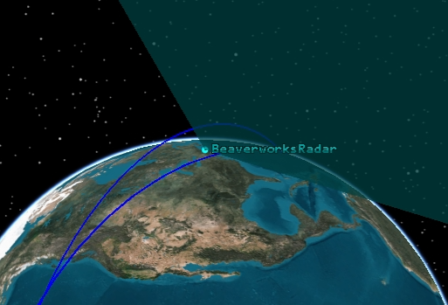
Figure 1: Simulation showing field of view of radar with track of the ISS.
Because RCS is aspect dependent, information about the RCS of each angle of the object must be uploaded. These measurements will be taken from a simplified model of a National Reconnaissance Office Lacrosse satellite, also known as Onyx [3]. The Onyx’s RCS file in the simulation contains the RCS measurement of 25 equally spaced points in a spherical coordinate system around the satellite; values between those 25 points are interpolated. Real world RCS measurements are expensive and time consuming so for our use case we resort to approximate RCS model calculations.
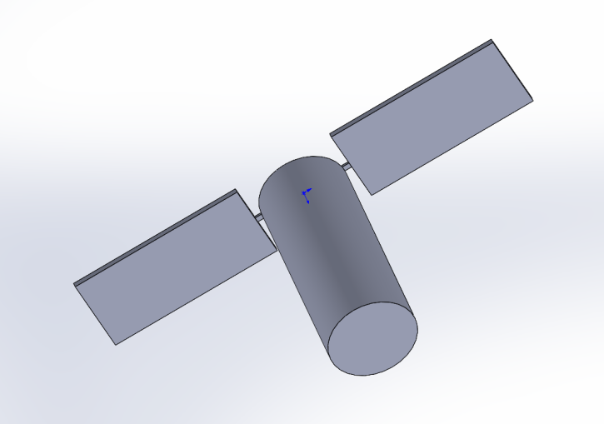
Figure 2: Simplified 3D model of NRO Lacrosse satellite used for RCS simulation. Model recreated for this project by Liam Dunphy.
The satellite in the simulation is poised to pass the radar’s field of view every 90 minutes. Playing the scenario and using the radar to track the satellite we gather that the average RCS of an attitude controlled satellite is stable. The satellites attitude can be adjusted in the software to simulate a less stable RCS from a rotating satellite.

Real World Data
Since the POSNEG has not been fully adopted by GBRs, there is no current database of pass by pass RCS. With the help of space operators, the RCS data used to calibrate the model was collected by hand for this project.
On some examples in the dataset, groups of passes follow a predictable curve. There is a jump in RCS when the satellite’s orbit takes it out of the field of view of the radar for multiple passes. An initial model will be trained on each grouping of passes since it seems to exhibit the most obvious pattern. A future model may predict the RCS over longer periods with more data but for the scope of this paper we will focus on one grouping at a time.

Predictive AI Model
The deep neural network architecture consists of an input layer, three hidden dense layers, and a single unit output layer. Since we only have one input variable, the common rule of thumb is to use few hidden layers. One hidden layer can approximate functions for less complex data such as simple mappings from one space to another [4]. The model does not currently predict when the satellite will be out of view of the radar entirely but in actual implementation the algorithm will only be run on times where the GBR anticipates it will observe the satellite using orbital analysis.

Implementation and Deployment

The POSNEG’s Tech Stack and Enviornment
In late 2022 a new digital POSNEG was built by Space Delta 4’s Combat Developments Team (DEL 4 CDT) available on SIPR through the Delta Analysis Reporting and Tracking System (DARTS). The new POSNEG is currently in beta testing; this upcoming software modernization gives us an opportunity to integrate a solution directly into mission planning software.
Since the POSNEG is hosted on DARTS, it conforms to a web based tech stack. Space Force Supra Coders are almost universally trained on web development. Web apps are particularly advantageous because web browsers are already vetted and installed on government computers. It also lends well to agile practice because new versions are immediately available online without installing updates. Multiple other AI products such as DALL-E and ChatGPT employ web user interfaces.
Supra Coders creating apps on existing platforms such as DARTS can be a quick way to develop a software solution instead of creating a standalone application. The POSNEG and other apps utilize DARTS’ Certificate to Field (CtF) to perpetually deploy changes and new microservices through Platform One and ODIN. DARTS was updated for this project to run TensorFlow through TensorFlow.js. It’s also possible to utilize its extra container for python libraries such as PyTorch. Any app on DARTS, current or upcoming, will be able to leverage these libraries for AI development.

Feature in Production
The DEL 4 CDT utilized the RCS prediction algorithm to build an alert feature in the POSNEG. If the object’s RCS values are unstable, the POSNEG displays a warning in the pass’ line. Hovering the cursor over the alert displays more information on previous RCS values and the predicted RCS of the upcoming pass. This feature is being is being used in mission planning as a part of the POSNEG beta testing at various space warning squadrons in DEL 4.
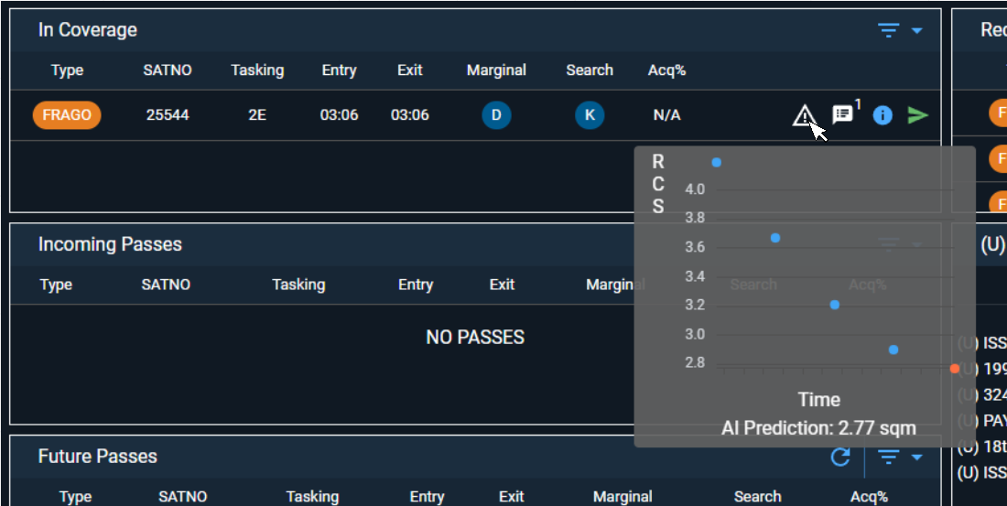
Figure 3: Screenshot of the alert feature in the POSNEG with mock data.

Evalutate and Iterate
The feature was delivered in line with the agile principal of early value delivery. We anticipate the training data may not be consistent with the entire range of real world circumstances. As of the writing of this paper the feedback process is ongoing. DEL 4 CDT will build upon the feature incrementally by examining evolutions in data and collecting feedback from users.

MetaProcess
This process could be duplicated to rapidly deploy other machine learning capabilities to the Space Force, potentially being a pipeline to operationalize AI in the future.

Relevant Organizations
Keeping with the impact paper’s topic to address a problem related to one’s home unit, this development effort is an extension of the Combat Developments Teams’ (CDT) mission to innovate and acquire cutting edge technology. They commonly leverage external organizations such as software factories and contractors as well as their own resources to realize these developments. Almost every delta in the Space Force has a CDT and each is responsible for a specific mission area. Many localized problems may be discovered and solved by AI at the CDT level. These innovations may be widely applicable to multiple subordinate units in the delta performing similar or identical missions. The following organizations are relevant to this project and highlight key relationships in Space Force software development.

Combat Developments Teams: Formerly known as Combat Developments Divisions (CDDs), this type of organiziation was borrowed from US Army Special Operations Command. A CDD may enable procurement of specialized hardware or the development of specific software. CDDs were adopted and later renamed to Combat Developments Teams to better reflect their smaller size in the Space Force. CDTs are sometimes staffed with their own internal development teams or more ordinarily a few Supra Coders. DEL 4 CDT has its own internal software development team with Supra Coders, contractors, and reservists working on multiple projects in various stages of application lifecycle.

SpOC and Deltas: Space Force operations are centralized under Space Operations Command (SpOC). Below SpOC there are 9 Space Mission Deltas each with their own function. Of particular interest to this project is Space Delta 4 (DEL 4) responsible for missile warning. DEL 4 is the parent organization of the space warning squadrons operating all ground based radars with the exception of the GBR at Eglin. The space warning squadrons’ primary mission is to watch for ICBMs; however, the radars often have the bandwidth to perform their collateral mission of SDA associated with Space Delta 2.

Software Factories: The Air Force has multiple software factories providing continuous integration and delivery (CI/CD) of applications. Software factories that commonly work with the Space Force include Kessel Run, Section 31 Kobayashi Maru, and Space Camp. Each of these software factories leverage different pipelines and hosting enviornments for a continuous authority to operate. These CI/CD pipelines allow for secure and perpetual changes to the code. Software factories commonly retain their own teams but they also work closely with CDTs. To illustrate this relationship, DEL 4 CDT is counted as a product team developing two apps with Space Camp and maintains an additional app on Kessel Run’s pipeline.

Department of the Air Force Massachusetts Institute of Technology Artificial Intelligence Accelerator: The DAF-MIT AI Accelerator, sometimes shortened AIA, consists of military and government personnel working in conjunction with Lincoln Laboratory (LL) and MIT to perform fundamental AI research in a broad range of areas to improve DAF operations. AIA Projects typically have MIT principal investigators, LL leads, and AIA government liasons. A phantom fellow may also be attached to a project to support project management, assist with research, and provide operational expertise.

CDT-AIA Product Development Process
The product development process can be broken down into four stages: discover, design, develop, deploy. Most product and feature work tend to go through these stages in a linear fashion. This section highlights the roles of Space Force organizations in each task. The case study of deploying an AI based RCS prediction feature is an instance of the process materialized.
CDTs perform regular discovery interviews with their subordinate units. The weapons and tactics shop of a space warning squadron brought up the RCS variation issue. It is crucial to have a large number of guardians educated about AI to identify possibilities for modernization in the force at large and especially in the CDTs.
Support from the AIA could be a key relationship in the design phase. The CDT could be added as a stakeholder to an existing project or a project may justify an entirely new funded research effort. Most likely the AIA will advise the CDT with the help of a phantom fellow. The phantom fellow could leverage resources such as the MIT SuperCloud or consult experts at LL.
Once the AIA and CDT collaborate on a design, a minimum viable product can be developed in the form of an algorithm or model. The coding can be done through Supra Coders, internal development teams, software factories, or contractors. There are a few avenues for building an AI tool without certifying a standalone application. DARTS in particular now has the proper packages installed to implement TensorFlow and its models. One can also implement AI on data platforms like Warp Core as seen in [5].
Iteration and incremental delivery is essential to the agile process [6]. A common issue that may be encountered is the discrepancy between training and real world data. This issue may be pronounced in the case of models trained on unclassified or simulated data but operating on real world classified data once deployed. The AIA should continue to be consulted for further recommendations on later iterations.

Technology Transition
A successful transition expects the AI to be implemented and operationally in use. The stated mission of the AIA is to “create a(n)… end-to-end… pipeline for AI technology”. Programs at the AIA must overcome a proverbial valley of death where matured science may fail to become a competitive advantage for the military if they are not transitioned. The agile process was partially designed to overcome this hurdle by delivering small incremental value to the customer. Incorporating the design and development done at the AIA into the agile feedback loop coordinated by CDTs may improve successfully transitioned project numbers.
In the case of the Space Force, CDTs at the deltas and government liaisons at the AIA should bridge the gap between research and implementation. Government liaisons at the AIA manage stakeholders and CDTs offer a link to the customers in their subordinate units. Members of the CDTs also contribute expertise from oftentimes having been in the same position as the users as well as being versed in computer science.

Conclusion
We can use AI regression to predict future satellite RCS values. With collaboration between the AIA and CDT this AI capability was rapidly deployed to space operators. There are many local problems ready to be solved with AI. Soon AI techniques may be nearly universal in Space Force software. This project demonstrates that our existent platforms and pipelines are ready to receive AI enabled applications.
The relationship between the AIA and Space Force CDTs can help bridge the valley of death; the AIA and CDTs will be briefed on this position at the Phantom Fellowship Capstone and the CDT Tag Up respectively. The AIA is producing world leading AI research applicable to DAF operations. The CDTs are modernizing development operations enabling the rapid deployment of new software. Linking these two already successful programs will accelerate innovation by opening the flood gates for AI in the Space Force.

Acknowledgment
This project would not have been possible without the support of guardians around the country. I’d like to thank Education with Industry Intel Corp Fellow TSgt Raymond Kell for his expertise and contribution to the project’s AI codebase, Anchor DARTS Developer Specialist Cybyl Hancock for her help deploying, DOK Space Operator Lieutenant Anna Pinkerton for her insights on RCS data, Supra Coder Councilman Captain Scott Hubert for his help in the discovery effort, and DEL 4 CDT Director Captain Whitney Hessler for her overall support in this endeavor.

References
- R. Sridharan and A. F. Pensa, ‘Us space surveillance network capabilities’, in Image Intensifiers and Applications; and Characteristics and Consequences of Space Debris and Near-Earth Objects, 1998, vol. 3434, pp. 88–100.
- R. M. O. O'Donnell, “Target Radar Cross Section,” in Introduction to Radar Systems, 25-Jul-2018.
- S. S. Chung, ‘C166. The Radar Cross Section of Known Low Observable Satellite Shape’, 03 2013.
- J. Heaton, Introduction to neural networks with Java. St. Louis: Heaton Research, 2005.
- L. Kenworthy, Advantages and Challenges of Modern Data Practices in Space Operations, 2022.
- K. Beck et al., ‘The agile manifesto’. 2001.

Appendix: About Supra Coders
Supra Coders are Z-prefixed personnel designated for “Agile Software Development and Cyberspace Engineering”. They are primarily active duty Guardians with some exceptions in the reserve, guard, and civilian service. Other branches have their own respective programs such as Airmen, Marine, and Army Coders. The Space Force designates their coders with prefixes and billeted positions. Supra Coders can come from any career field and often have a primary specialty unrelated to software such as space operations, intelligence, acquisitions, etc. They use this blend of expertise to augment various units with development capability; this makes Supra Coders particularly knowledgeable about the needs of the end user.

The ISS has an RCS of about 402 sqm or 26 dbsm.
PAVE is a United States Air Force program identifier relating to electronic systems.
POSNEG is a short hand for positive negative acquisition, used to describe a mission planning board listing expected passes and taskings.
RCS data is controlled unclassified information. To see figures of changing RCS from the dataset, including from satellites with above average maneuver capability, contact the author.
See appendix for more about Supra Coders.
Warp Core is a Data as a Service platform that has the ability to integrate python code and create dashboards.
The Valley of Death is a commonly used phrase to describe a difficult phase to overcome such the leap from launch to revenue generation or prototype to DoD contract.

